Trabalho 2

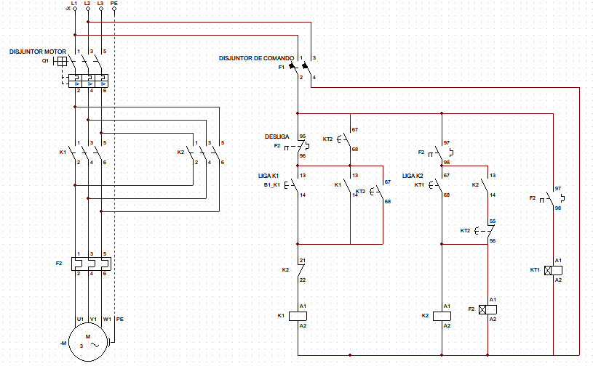

Link para o vídeo:

https://drive.google.com/drive/folders/1sGGI9FG_2n-SPSyG1xnXpnGaLj2_7N1O?usp=sharing